Assignment Report –

Model Equation -

y = 180.562934 +

1.62808515e-01x1 -1.26970694e+00x2 + 0.000x3 + 6.09620919e-01x4 + 1.78063973e-01x5 -1.36394775e-02x6 + 3.63711436e-01x7 -1.19512751e+00x8 -6.73263506e-01x9 + 7.92561576e-01x10 -9.41702676e-02x11 + 1.12131374e-03x12 + 8.16549604e-02x13 -6.72632625e-01x14 + 3.59095660e+00x15 + 4.04815575e+00x16 + 9.22946165e-02x17

1. Lasso gave the best results with

Rmse – 18.54

Mean squared error – 344

3)

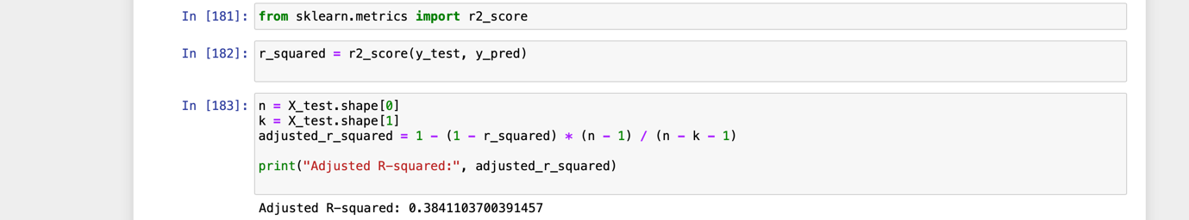

4)have attached the ipynb file

5) have assessed linearity and multicollinearity

6) have used k fold

7) outliers were present have handled it , missing values were there have imputed with mean , categorical variable was hash encoded , EDA and univariate analysis was done